K.H GOVERNMENT DEGREE COLLEGE
DHARMAVARAM
APPGCET/I-CET 2018-2023
2022-23
- N. DADAKHALANDAR, I- CET-2022
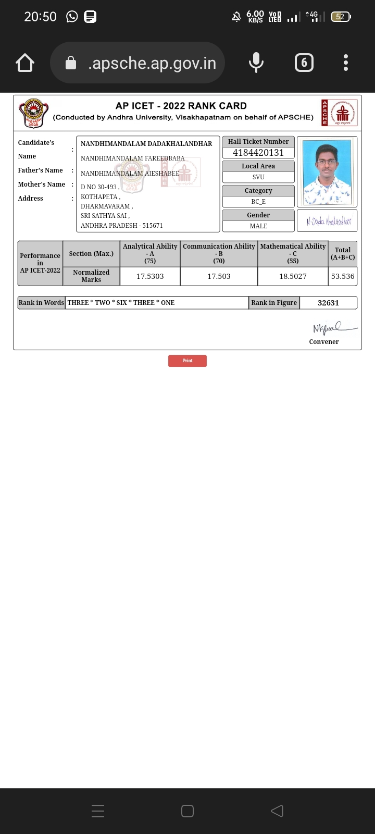

- G. NAVEEN KUMAR, I-CET-2022
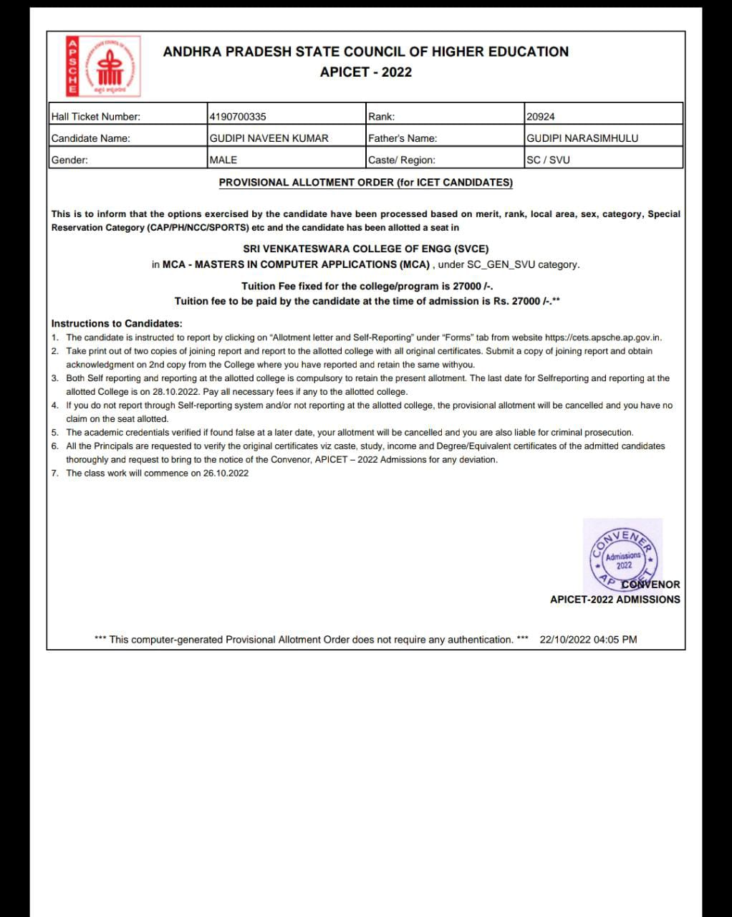

- K. RAVINDRA KUMAR, I-CET-2022
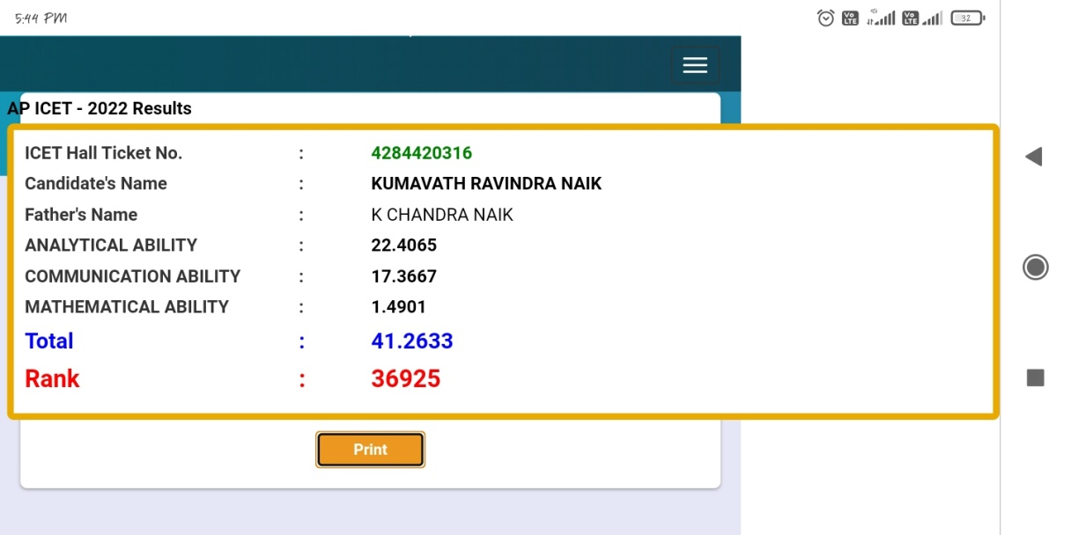
- K. ANIL KUMAR NAIK, I-CET-2022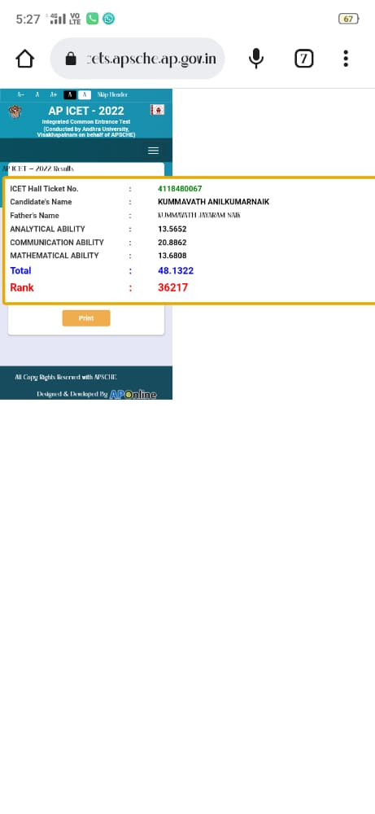

- E. MANJUNATH, I-CET-2022
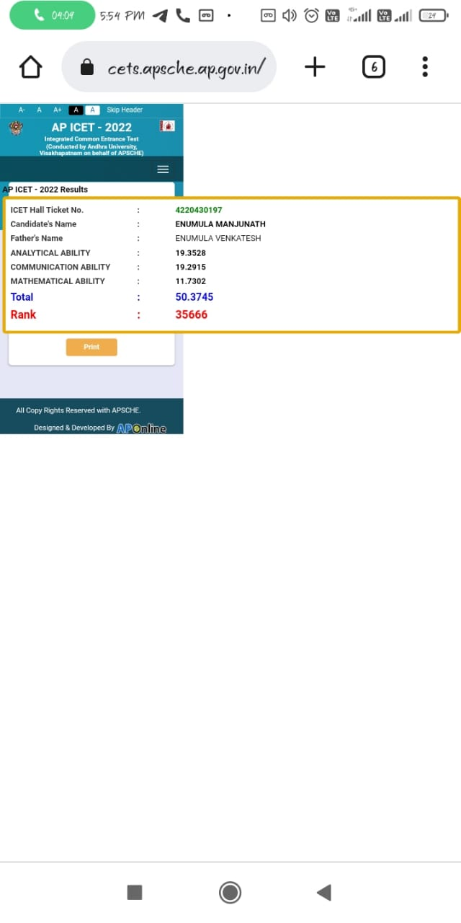

- S. BABAVALI, I-CET-2022
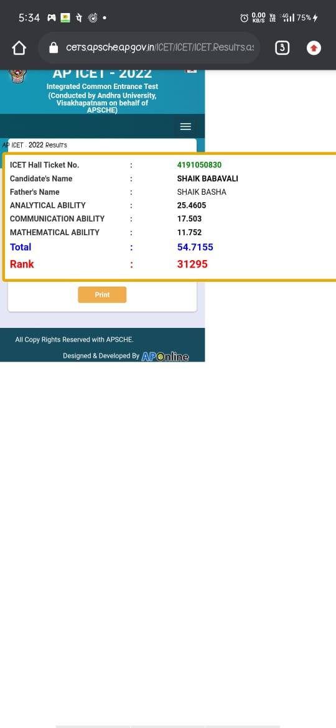
- S. GANESH, I-CET-2022
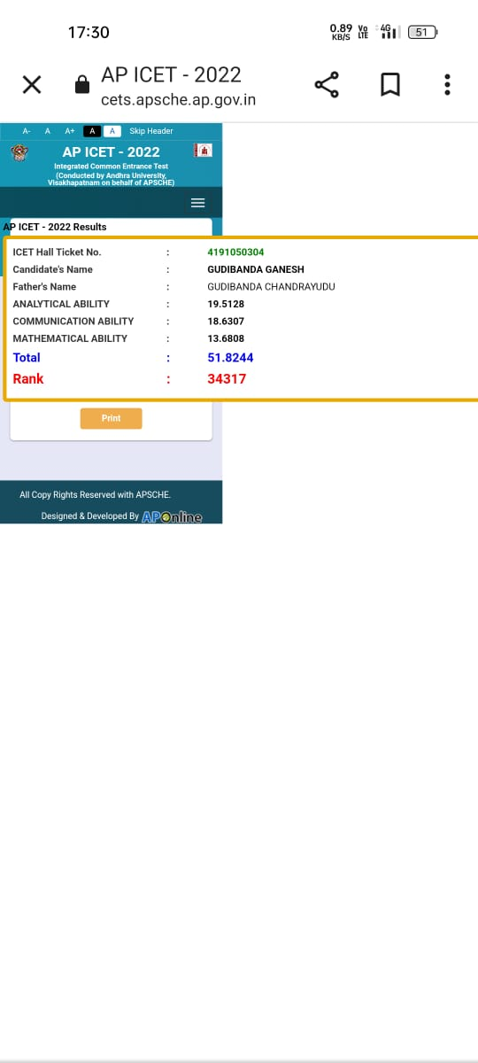

- B. MOHAN KRISHNA, I-CET-2022

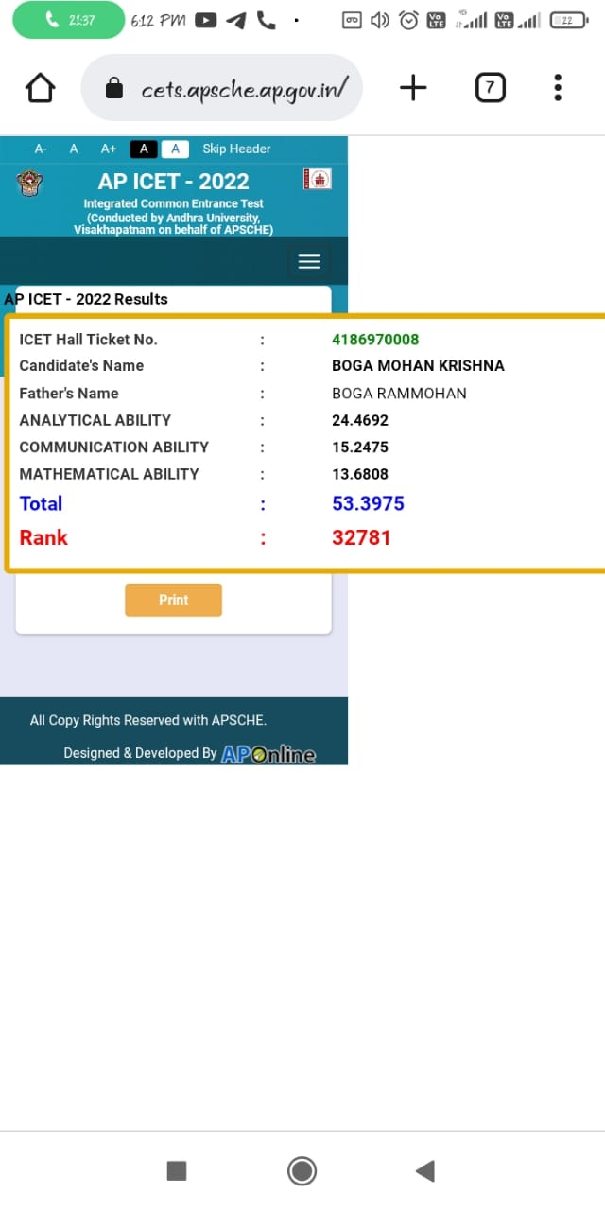

- K. CHAITANYA KUMAR, I-CET -2022
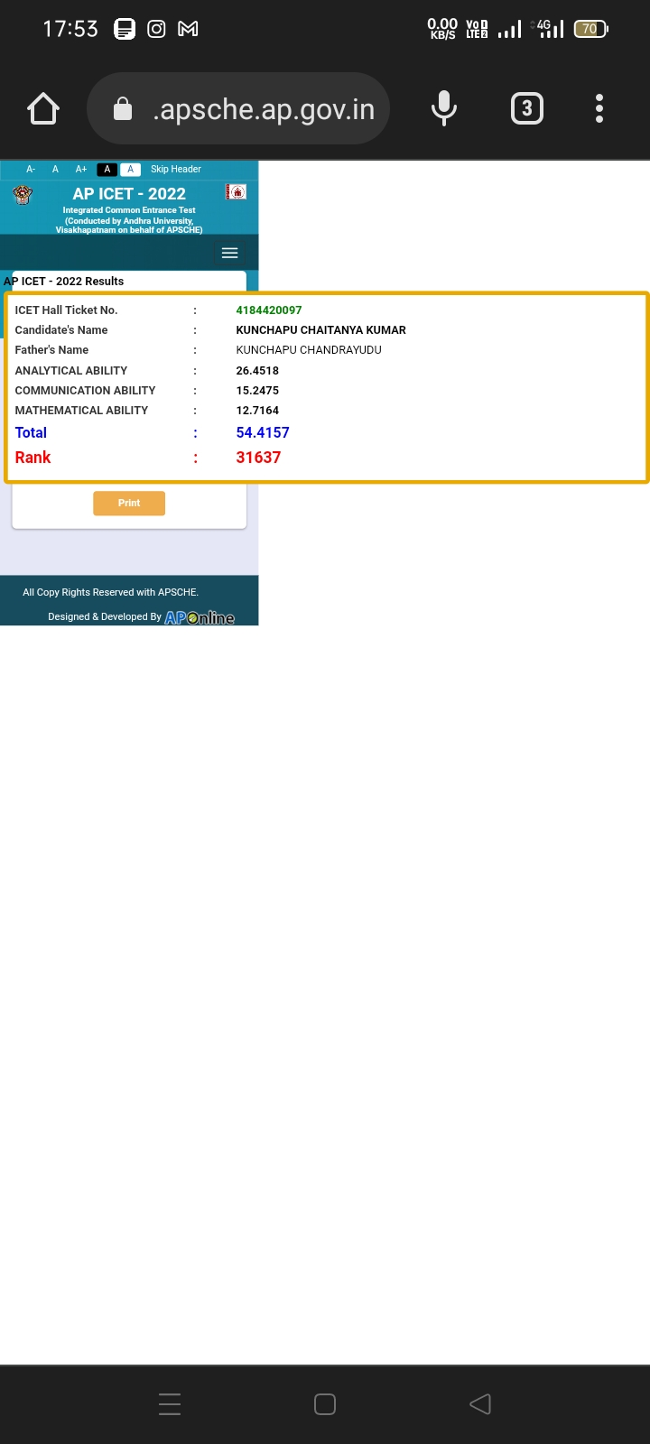

- M. SISINDRI, I-CET -2022
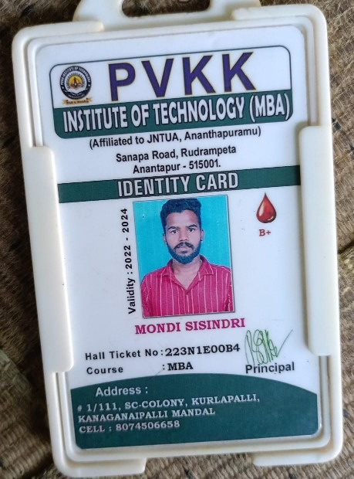

- U. CHANDRA SEKHAR, APPGCET-2022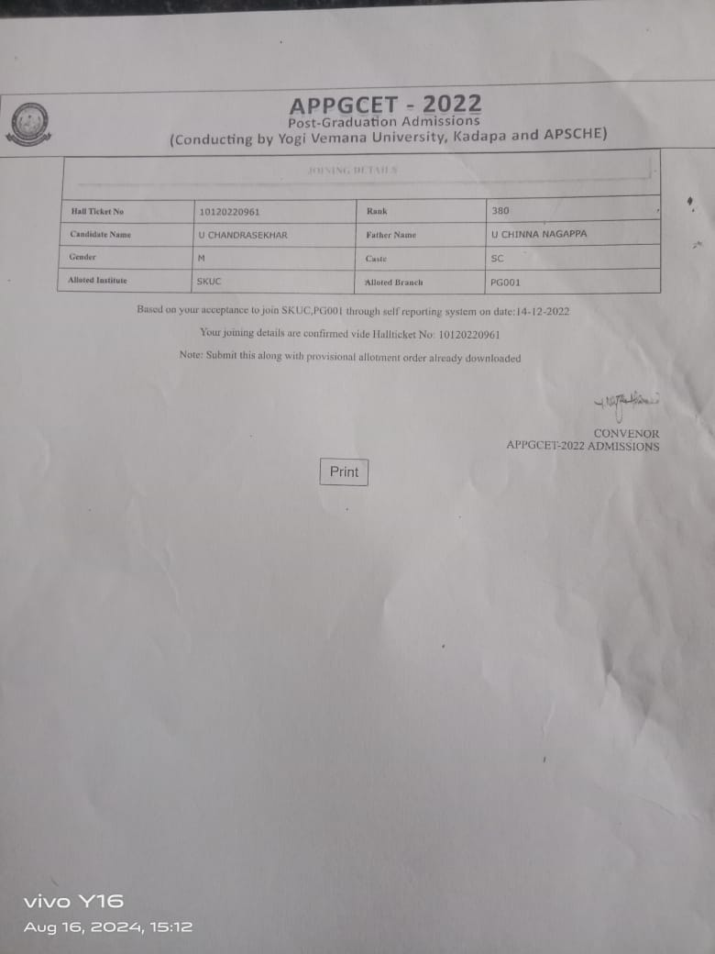

- K. CHAITANYA KUMAR, I-CET -2022

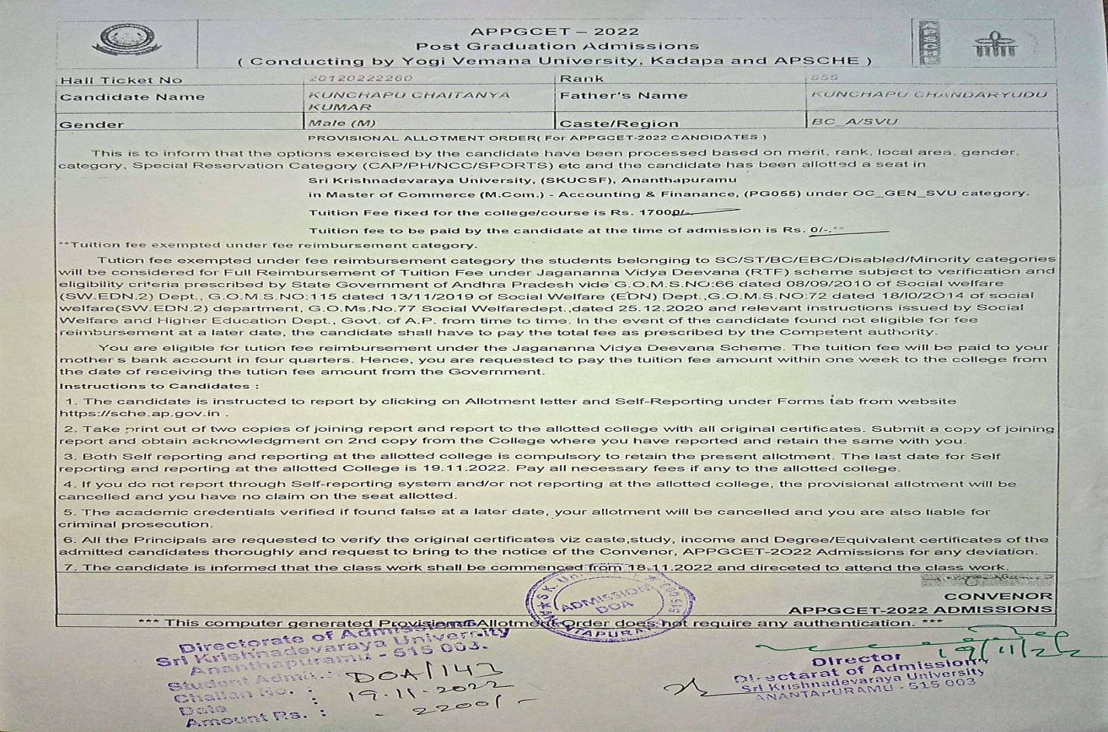

- G.P.S.Y. SARASWATHI,
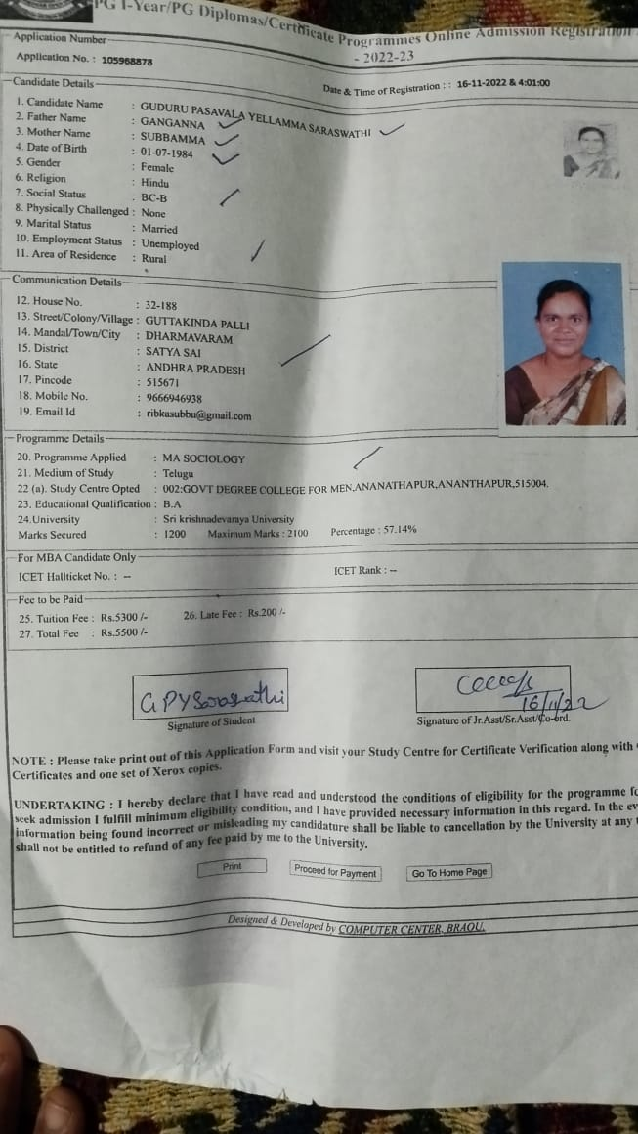

2020-21
- MARUTHI KUMMARI, SKUCET-2020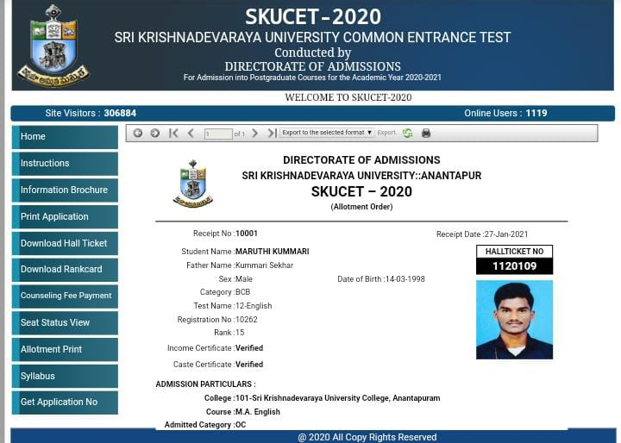\
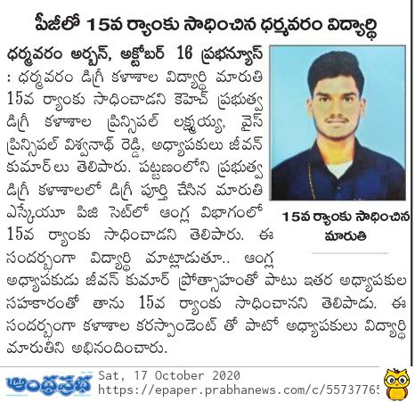

K.H GOVERNMENT DEGREE COLLEGE, DHARMAVARAM
APPGCET/I-CET 2018-2023
5.2.2 Percentage of students qualifying in state/national/ international level examinations during the last five years (eg: IIT/JAM/NET/SLET/GATE/GMAT/GPAT/CLAT/CAT/ GRE/TOEFL/ IELTS/Civil Services/State government examinations etc.)
Year | Registration Number/roll number for the exam | Names of Students qualified | Name of the qualifying exam
2022-23 | 4184420131 | N. DADAKHALANDAR | I-CET
 | 4190700335 | G. NAVEEN KUMAR | I-CET
 | 4284420316 | K. RAVINDRA KUMAR | I-CET
 | 411840067 | K. ANIL KUMAR NAIK | I-CET
 | 4220430197 | E. MANJUNATH | I-CET
 | 4191050830 | S. BABAVALI | I-CET
 | 4191050304 | G. GANESH | I-CET
 | 4186970008 | B. MOHAN KRISHNA | I-CET
 | 4184420097 | K. CHAITANYA KRISHNA | I-CET
 | 223N1EOOB4 | M. SISINDRI | I-CET
 | 10120220961 | U. CHANDRASEKHAR | PGCET
 | 20120222260 | KUNCHAPU CHAITANYA KRISHNA | PGCET
 | 105965878 | G.Y.P. SARASWATHI | PGAOU
2020-21 | 1120109 | K. MARUTHI | PGCET

